

**Overview**

The client, Courtney Harding, of L’escape Travel by Courtney, is looking to have a website built to inspire her potential customers’ confidence and grow her business. Especially during this pandemic, she wants to assure her clients that she is informed and experienced to plan and troubleshoot any vacation. She also wants this site to expression both her professionalism and passion for travel.

This website will help her to reignite her previously thriving business now that vaccines are being distributed and travel is becoming more popular again. This website is meant to be a way for potential clients to learn about her, her business, her expertise, and how to connect with her.

**Design**

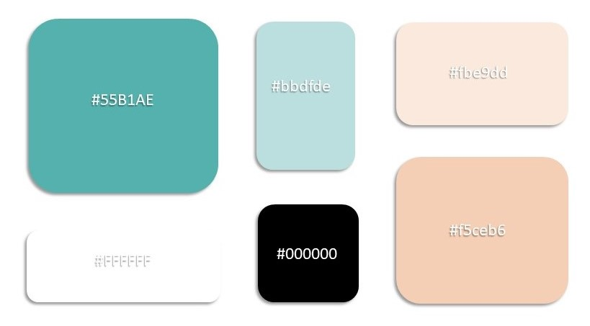The client has asked for a bright and modern looking site. Beach and ocean colors were chosen for the pallet of this site. These colors were consistently used throughout the site for backgrounds, links, and icons. The font used throughout this site was Calibri light. This font was simple, modern, and easy for users to read. The buttons, foreground shapes, and title banners all had rounded edges with shadows to give the site a three dimensional and simplistic feel.

The images chosen for this site were also simplistic in nature and followed a similar color scheme to the rest of the site. Many of the images were of beach or tropical scenery, meant to convey to the viewer a sense of relation.

**List of Technologies**

This website is made mostly using HTML 5 and CSS 3. JavaScript is used for embedding the Facebook reviews on the *Reviews* page and for the social media links on each page. These files can be viewed or altered easily using most text editors. These files are also available and alterable on GitHub. The repository link is <https://github.com/Summer-Finch/LescapeTravelByCourtney> . Depending on the hosting option chosen by the client, the following technologies may be used at well: Git version 2.31.1-64, FileZilla Client 3.54.0-rc1.

**Configuration Information**

The HTML and CSS files for this website are found in the *website files* folder. The images for this site are found in the *images* folder inside of *website files*. These two folders contain everything needed to deploy the site. For instruction on how to do so, refer to the **Hosting** section below. Also, the release form for each image used can be found in the *image release forms* folder.

**Hosting**

For hosting, there are two recommended options for the client. With regards to either option, it suggest that the client purchase a domain name for their website from <https://www.namecheap.com/>. The “.com” option is $8.88 per year plus tax.

The first suggestion is free except for the previously mentioned domain name purchase. This option is ideal if the client is having a small amount of traffic to their website and only needs use of the the basic functionality it currently includes.

The second suggestion will allow the client more scalability and options for increased functionality in the future. As of May 10, 2021, the best cost for this second service is $4.99/mo. if a one-year package is purchased upfront. This would bring the cost ($59.98 for one year of hosting plus $8.88 for one year of domain name use) total to $68.88 plus tax.

**OPTION 1**

For this option, the client will need to first create an account on the following two site:

<https://github.com/> and <https://www.netlify.com/> . They will also need to install Git from <https://git-scm.com/downloads> . If the client is using a 64-bit machine, they can download Git version 2.31.1-64 for their device. Next, they will need to create a repository on their GitHub account. They can then follow these instructions to push the files for their website to this repository:

Open Git Bash Terminal

You may need to configure Git Bash by using the following commands:

* + git config –global user.email “[your@email.com](mailto:your@email.com)”
  + git config –global user.name “Your Name”

Change directory to folder containing files for website by using the command:

* + cd [path name]

From there, use the following commands to push files to repository:

* + git init
  + git remote add origin [gitLink found on gitHub repository creation page]
  + git remote -v
  + git add .
  + git commit -m "first commit"
  + git branch -M main
  + git push -u origin main

You may be asked to authenticate your Git Hub account in the browser before Git Bash begins uploading your files to the repository. To end session, use command:

* + exit

Next, inside your Netlify account page, click on “Sites->”, then “New Site from Git”, then “Git Hub”. You may need to authenticate your Git Hub account here as well. Then you will see the list of your repositories. Select the recently created repository for the L’escape Travel website, be sure the branch to deploy is ‘main’ and click “deploy site”. Netlify will provide you with a randomly generates url. From here, we can link it to our previously purchased domain name by following the link “Set up a custom domain” on the ‘Site Overview’ page under ‘Getting Started’.

Finally, to have form submissions from the site sent to your email, you can update your forms setting in your Netlify account by clicking the following links: “Site settings” > “Forms” > “Form notifications”. More information on this can be found at <https://docs.netlify.com/forms/notifications/> .

**OPTION 2**

For this option, it is recommended the client use [https://www.inmotionhosting.com/](https://www.inmotionhosting.com/%20) . After purchasing which ever service the client chooses (low-cost suggestion described at the beginning of this section), within their account page there will be a link to add an FTP Account. Click on this link and fill out the required information and input the path to the root file. Click “Create FTP Account” button. Next, the client will need to use an FTP client to access the files. One suggestion is to download the server option from <https://filezilla-project.org/> . Open FileZilla and input the purchased domain name into the box labeled ‘Host’. In the Username and Password text boxes, input the username and password that was created for the FTP account. Port 21 is the default and does not need to be filled in. Click “Quick Connect”. Under remote site, go to ‘/public_html’, delete the prepopulated landing pages inside and upload the website files. The website should now be live. The client can use the Inmotion account to set up an email for form submissions from website users. If they would prefer, there is a PHP option on the Inmotion account. Included in the website files folder is process.php. The action within the form will need to be changed on the 5_start_planning.html page to action=”process.php”.